SAC Outstanding Service Award: 2018

Congratulations to Sandra Post – first recipient of the Samoyed Association of Canada’s Outstanding Service Award.

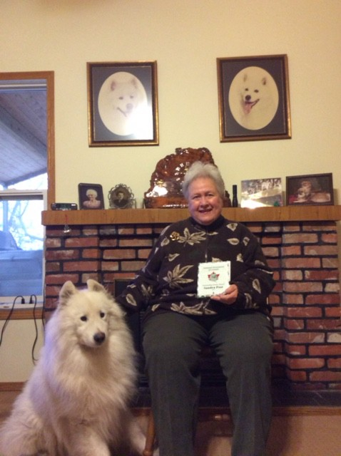

Sandra Post has dedicated her life to the Samoyed breed in countless ways. For many years she and her husband Jack bred sound and healthy dogs under the kennel name Jasam. Her line has provided foundation dogs for subsequent lines (among others, Gandale and Winterdance), and the Jasam prefix still figures in some of today's pedigrees. Two notable dogs she bred are MBIS and BISS Ca Am Ch Jasam's Viktor and multiple Best in Show winning bitch, Ca Am Jasam's Rocky Mtn High, both of whom were top winning dogs in Canada in the 80's. She and husband Jack were also involved in sledding with their Samoyeds and indeed a number of their dogs were featured in a Hollywood film!

Always a willing volunteer, Sandra has served the National Club in a number of positions on the executive (Vice President 1992-1994, Prairies director 1994-1995, Treasurer 1997-2001), and she was editor for the Sammy News for a number of years until 1981, back when it was LOT more labour intensive! Sandra has also been the chair of the Education committee for SAC since 2007. She has chaired a number of Specialties, both National and Regional, for Alberta and Western Canada, and has been a generous donor to trophy funds at Samoyed events. Rescue situations in which a Samoyed needs fostering, transport etc. have been able to count on Sandra to step up to help.

On the SAC website she is acknowledged as contributing her expertise to the "Breed Presentation" an extremely thorough PowerPoint presentation on all things Samoyed. At the 2009 specialty held in Chilliwack BC Sandra presented a seminar to exhibitors, judges and

Sammy fanciers alike. It was well received by everyone. Sandra has presented breed seminars for judges' education, amongst others for the Vancouver Island Judges Group in 2006, for the "Parade of Spitz" breeds seminars. Overall, she never misses an opportunity to mentor new judges and new exhibitors. She is generous with her time, experience and extensive knowledge of the Samoyed breed and a wonderful resource for those just starting out in the breed.

Sandra sends the following message:

I was so surprised to receive this honour! Thank you so much on behalf of all the Jasam Samoyeds as well as myself, my late husband Jack, and all of the wonderful Samoyed fanciers we have met over the years. I hope as long as I live that I can always have a Samoyed in my life!
With deep gratitude ....Sandra Post

